##### Doctor Appointment Scheduler

**DSN4097 INTERNSHIP REPORT**

###### ***Submitted by***

##### Anshita Banthia

**(20BCE10425)**

*in partial fulfillment for the award of the degree*

*of*

##### BACHELOR OF TECHNOLOGY

*in*

**Computer Science Core**



**SCHOOL OF COMPUTING SCIENCE AND ENGINEERING**

**VIT BHOPAL UNIVERSITY**

**KOTHRIKALAN, SEHORE**

**MADHYA PRADESH - 466114**

April - 2024

**A PROPOSED DESIGN AND IMPLEMENTATION OF IOT BASED SMART WATCH FOR MONITORING APP**

**DSN4097 INTERNSHIP REPORT**

###### ***Submitted by***

##### Anshita Banthia (20BCE10425)

*in partial fulfillment for the award of the degree*

*of*

**BACHELOR OF TECHNOLOGY**

*in*

# COMPUTER SCIENCE AND ENGINEERING



**SCHOOL OF COMPUTING SCIENCE AND ENGINEERING**

**VIT BHOPAL UNIVERSITY**

**KOTHRIKALAN, SEHORE**

**MADHYA PRADESH - 466114**

##### MAY 2024

(A typical specimen of Bonafide Certificate)

**VIT BHOPAL UNIVERSITY, KOTHRIKALAN, SEHORE**

**MADHYA PRADESH – 466114**

**BONAFIDE CERTIFICATE**

Certified that this project report titled **“……….Book a Doctor……………..”** is the bonafide work of “**…Anshita Banthia. (Register No: 20BCE10425)”** who carried out the project work under my supervision. Certified further that to the best of my knowledge the work reported at this time does not form part of any other project/research work based on which a degree or award was conferred on an earlier occasion on this or any other candidate.

**PROGRAM CHAIR PROJECT GUIDE**

Dr. J Manikandan, Assistant Professor, Dr. Vijay Kumar Trivedi

School of Computing Science and Engineering School of Computing Science and Engineering

VIT BHOPAL UNIVERSITY VIT BHOPAL UNIVERSITY

The Internship Examination is held on 02/07/2023

**Smart Bridge Externship Certificate**



**AWS Cloud Practitioner Score card and Certificate**





**ACKNOWLEDGEMENT**

First and foremost, I would like to thank the Lord Almighty for His presence and immense blessings throughout the project work.

I wish to express my heartfelt gratitude to Dr. Poonkuntran S, Head of the Department, School of Computer Science for much of his valuable support encouragement in carrying out this work.

I would like to thank my internal guide Mr./Ms. Vijay Kumar Trivedi, for continually guiding and actively participating in my project, giving valuable suggestions to complete the project work.

I would like to thank all the technical and teaching staff of the School of Aeronautical Science, who extended directly or indirectly all support.

Last, but not least, I am deeply indebted to my parents who have been the greatest support while I worked day and night for the project to make it a success.

**LIST OF ABBREVIATIONS**

1. FRD: The Functional Requirements Document

2. NFRD: Non-functional Requirements Document

3. UI: User Interface

4. MVC: Model-View-Controller

5. JPA: Java Persistence API

6. CRUD: create read update delete

**LIST OF FIGURES AND GRAPHS**

|  |  |  |
| --- | --- | --- |
| **FIGURE NO.** | **TITLE** | **PAGE NO.** |
| 4.3.1 | Flowchart Of our Approach |  |
| 4.3.2 | Functions in System |  |
| 4.4.1 | Home Page UI |  |
| 5.2.1 | Appointment main.java |  |
| 5.2.2 | Home.html |  |
| 5.2.3 | Controller class |  |
| 5.3.1 | Login Style.css |  |
| 5.3.2 | Patient List.html |  |
| 5.3.3 | Home Page Styling |  |
| 5.6.1 | Growth of Health care Industry in India |  |
| 5.6.2 | Cost to develop Healthcare Application |  |
| 5.6.3 | Fund Raising Deals by Health Startups |  |
| 6.3.1 | Welcome Page |  |
| 6.3.2 | Home Page |  |
| 6.3.3 | Appointment Page |  |
| 6.3.4 | Doctors Login |  |
| 6.3.5 | Doctors Registration |  |
|  |  |  |

**ABSTRACT**

By addressing the need for effective scheduling systems in contemporary healthcare settings, the Doctor Appointment Scheduler represents a significant advancement in healthcare appointment management. In order to create a user-friendly platform that optimizes resource allocation for healthcare organizations while streamlining scheduling and improving user experience, this study introduces a web-based application for appointment booking. The project makes use of web technologies to let users browse time slots, choose appointments, and get immediate confirmations by fusing software development methodologies with user-centric design concepts. Thorough testing guarantees flawless functionality, and feedback channels promote ongoing enhancements.

Increased convenience and satisfaction reported by users demonstrate the Doctor Appointment Scheduler's successful implementation.

A flawless booking experience is enhanced by real-time availability updates, an easy-to-use interface, and automated error detection that reduces scheduling conflicts and boosts operational effectiveness. The impact of technology integration in healthcare appointment management—from manual to automated processes—is highlighted in the discussion. The Doctor Appointment Scheduler improves organizational efficiency and patient care by lowering administrative burdens and increasing accessibility. Sustained improvements are imperative to ensure the system's efficacy in the dynamic healthcare environment.

**TABLE OF CONTENTS (SPECIMEN)**

|  |  |  |
| --- | --- | --- |
| **CHAPTER NO.** | **TITLE** | **PAGE NO.** |
|  | List of Abbreviations  List of Figures and Graphs  List of Tables  Abstract | iii  iv  v  vi |
| 1 | **CHAPTER-1:**  **PROJECT DESCRIPTION AND OUTLINE** Introduction 1.2 Motivation for the work  1.3 [About Introduction to the project  including techniques]  1.5 Problem Statement  1.6 Objective of the work  1.7 Organization of the project  1.8 Summary | 1  .  .  . |
| 2 | **CHAPTER-2:**  **RELATED WORK INVESTIGATION**  2.1 Introduction  2.2 <Core area of the project>  2.3 Existing Approaches/Methods  2.3.1 Approaches/Methods -1  2.3.2 Approaches/Methods -2  2.3.3 Approaches/Methods -3  2.4 <Pros and cons of the stated Approaches/Methods >  2.5 Issues/observations from investigation  2.6 Summary |  |
| 3 | **CHAPTER-3:**  **REQUIREMENT ARTIFACTS**  3.1 Introduction  3.2 Hardware and Software requirements  3.3 Specific Project requirements  3.3.1 Data requirement  3.3.2 Functions requirement  3.3.3 Performance and security requirement  3.3.4 Look and Feel Requirements  3.3.5 ………  3.4 Summary |  |
| 4 | **CHAPTER-4:**  **DESIGN METHODOLOGY AND ITS NOVELTY**  4.1 Methodology and goal  4.2 Functional modules design and analysis  4.3 Software Architectural designs  4.4 Subsystem services  4.5 User Interface designs  4.5 ………………..  4.6 Summary |  |
| 5 | **CHAPTER-5:**  **TECHNICAL IMPLEMENTATION & ANALYSIS**  5.1Outline  5.2 Technical coding and code solutions  5.3 Working Layout of Forms  5.4 Prototype submission  5.5 Test and validation  5.6 Performance Analysis(Graphs/Charts)  5.7 Summary |  |
| 6 | **CHAPTER-6:**  **PROJECT OUTCOME AND APPLICABILITY**  6.1Outline  6.2 key implementations outlines of the System  6.3 Significant project outcomes  6.4 Project applicability on Real-world applications  6.4 Inference |  |
| 7 | **CHAPTER-7:**  **CONCLUSIONS AND RECOMMENDATION**  7.1Outline  7.2 Limitation/Constraints of the System  7.3 Future Enhancements  7.4 Inference |  |
|  | Appendix A  Appendix B  References  ***Note: List of References should be written as per IEEE/Springer reference format. (Specimen attached)*** |  |

**CHAPTER-1:**

**PROJECT DESCRIPTION AND OUTLINE**

**1.1] Introduction**

The Doctor Appointment System is a sophisticated web-based application engineered to revolutionize healthcare booking processes. With a user-friendly interface, it facilitates seamless appointment scheduling for patients and users. By presenting available time slots and enabling users to select their preferred date and time, the system simplifies the booking process. Automated appointment allocation and real-time availability updates mitigate errors and ensure efficient management. Users benefit from the flexibility to cancel bookings at their convenience, enhancing overall convenience.

The system prioritizes usability, requiring no formal knowledge for operation, and features robust error detection mechanisms to validate data entry, thereby enhancing reliability. Through its emphasis on error-free, secure, and efficient appointment scheduling, the Doctor Appointment System aims to optimize resource utilization for healthcare organizations. By automating appointment management tasks, the system frees up valuable time and resources, allowing healthcare professionals to focus on delivering quality care to patients. With its promise of streamlining processes and enhancing user experience, the Doctor Appointment System stands as a beacon of innovation in the realm of healthcare scheduling solutions.

**1.2] Motivation:**

The motivation behind developing the Doctor Appointment Scheduler system stems from the need to streamline and enhance the process of booking appointments with doctors. Traditional methods of appointment scheduling often involve manual allocation by receptionists or healthcare providers, leading to inefficiencies, errors, and potential delays in patient care.

With the increasing demand for healthcare services and the limited availability of medical professionals' time, there is a pressing need for a more efficient and user-friendly appointment scheduling system. By implementing an intelligent and web-based appointment scheduler, patients and users can easily access available time slots, select convenient appointment times, and manage their bookings online.

The primary motivation of this work is to address several key objectives:

• Improve Accessibility: The system aims to provide patients with convenient access to appointment scheduling, allowing them to book appointments anytime, anywhere, without the need for physical presence or phone calls.

• Reduce Errors: Manual appointment scheduling processes are prone to errors such as double bookings, scheduling conflicts, and data entry mistakes. The system aims to minimize these errors by providing a user-friendly interface and validation checks for input data.

• Enhance Patient Experience: A streamlined appointment scheduling process improves the overall patient experience by reducing wait times, minimizing scheduling conflicts, and providing greater flexibility and convenience for patients.

Overall, the motivation behind developing the Doctor Appointment Scheduler system is to leverage technology to improve the efficiency, accessibility, and quality of healthcare services, ultimately leading to better patient outcomes and satisfaction.

**1.3] Problem Statement:**

Realizing you have a health issue that needs medical attention and treatment can cause

anxiety. Visiting doctor physically takes too much time in this tech era and is also

sometimes disappointing and frustrating. Instead of personally visiting the doctor and

describing your symptoms in order to receive treatment, seeing a doctor online for any

kind of periodical consultations seems to be a great option now.

Improved technology has made telemedicine easier where remote video consultations

between doctor and patient are technically possible and increasingly acceptable

Realizing you have a health issue that needs medical attention and treatment can cause

anxiety. Visiting doctor physically takes too much time in this tech era and is also

sometimes disappointing and frustrating. Instead of personally visiting the doctor and

describing your symptoms in order to receive treatment, seeing a doctor online for any

kind of periodical consultations seems to be a great option now.

Improved technology has made telemedicine easier where remote video consultations

between doctor and patient are technically possible and increasingly acceptable

Realizing you have a health issue that needs medical attention and treatment can cause anxiety. Visiting doctor physically takes too much time in this tech era and is also sometimes disappointing and frustrating. Instead of personally visiting the doctor and describing your symptoms in order to receive treatment, seeing a doctor online for any kind of periodical consultations seems to be a great option now. Improved technology has made telemedicine easier where remote video consultations between doctor and patient are technically possible and increasingly acceptable.

**1.4] Objective of the Work**

1. Automation of Appointment Scheduling: The primary objective of the project is to develop a system that automates and streamlines the process of booking appointments with doctors. This includes creating a web-based platform where patients can easily view available appointment slots and select their preferred date and time.
2. Enhancing Accessibility to Healthcare Services: Another objective is to improve the accessibility of healthcare services by providing patients with a convenient online platform for scheduling appointments. This allows patients to book appointments from the comfort of their homes or on the go, without the need for phone calls or in-person visits.
3. Minimization of Errors and Administrative Burden: The project aims to minimize errors in appointment scheduling and reduce the administrative burden on healthcare providers and receptionists. This is achieved through the implementation of validation checks and error messages for invalid inputs, ensuring accurate and reliable booking of appointments.
4. Optimization of Resource Utilization: The system seeks to optimize the utilization of healthcare resources, including doctors' time and clinic resources, by efficiently managing appointment slots and reducing no-shows or cancellations.
5. Improvement of Patient Experience: Lastly, the project aims to enhance the overall patient experience by reducing wait times, minimizing scheduling conflicts, and providing greater flexibility and convenience for patients when booking appointments.

By achieving these objectives, the Doctor Appointment Scheduler project aims to modernize and improve the appointment scheduling process in healthcare settings, ultimately leading to better patient outcomes and satisfaction.

**1.5] Summary**

Chapter 1 of the project report outlines the development of a sophisticated web-based Doctor Appointment System aimed at revolutionizing healthcare booking processes. The system offers a user-friendly interface facilitating seamless appointment scheduling for patients. It automates appointment allocation, provides real-time availability updates, and allows for flexible booking and cancellation. Emphasizing usability, the system requires no formal knowledge for operation and features robust error detection mechanisms to ensure reliability. Motivated by the need to streamline and enhance appointment scheduling processes, the project aims to improve accessibility, reduce errors, enhance patient experience, and optimize resource utilization within healthcare organizations. The problem statement highlights the challenges of traditional appointment scheduling methods and the growing importance of telemedicine in addressing healthcare needs. The objectives of the work encompass automation of scheduling, enhancing accessibility, minimizing errors, optimizing resource utilization, and improving patient experience. Overall, the project seeks to leverage technology to modernize and improve healthcare appointment scheduling, ultimately leading to better patient outcomes and satisfaction.

**CHAPTER-2:**

**RELATED WORK INVESTIGATION**

**2.1] Introduction**

The Doctor Appointment Scheduler project delves into the challenges inherent in traditional appointment scheduling methods for both patients and healthcare providers. It underscores the need for an intelligent system to simplify appointment booking while addressing issues of maintaining and scheduling appointments based on consumer preferences. The survey highlights the inefficiencies of manual booking processes, such as long queues and errors in data entry. The proposed solution is a web-based appointment scheduling tool that allows patients to browse available time slots and select preferred appointments conveniently. This system aims to eliminate the need for physical visits to hospitals or chemists, reducing wait times and streamlining administrative processes. Moreover, it addresses concerns of data accuracy by providing error messages for invalid inputs. Overall, the literature survey emphasizes the importance of implementing an efficient and user-friendly appointment scheduling system to enhance patient experience and optimize resource allocation in healthcare settings.

**2.2] Core area of the Project**

The core area of the project centers on developing an intelligent online appointment scheduling system tailored for patients and healthcare providers. By addressing the challenges inherent in traditional appointment booking processes, the system aims to streamline scheduling procedures and enhance overall efficiency in healthcare delivery. Patients often face the inconvenience of long queues and difficulty securing appointments at preferred times, issues which the system addresses by allowing users to browse available time slots and select suitable options. This feature mitigates the need for physical queues and reduces wait times, significantly improving the patient experience.

Moreover, the system automates appointment allocation based on user preferences and availability, minimizing scheduling conflicts and optimizing the utilization of doctors' time. The inclusion of yellow-marked slots to indicate unavailability further ensures effective management of appointments. Additionally, the system enables easy cancellation of appointments, providing flexibility for both patients and healthcare providers. With a strong emphasis on data accuracy and security, the system employs error detection mechanisms to prevent manual entry errors and safeguard appointment records. Its user-friendly interface requires no formal training, enhancing accessibility for all users. Overall, the core area of the project lies in developing a comprehensive Doctor Appointment System that streamlines scheduling processes, improves patient experience, and enhances resource allocation within healthcare organizations.

**2.3] Existing Approaches**

2.3.1] Time-Specified Scheduling :

As the name suggests, time-specific scheduling is when you schedule appointments at a specific time. Most offices use this method in order to minimize the amount of time patients spend waiting for the doctor. The allotted time usually depends on the reason for the visit. New patients and complete physicals are generally longer than urgent visits for an established patient. One potential concern with this scheduling method is that patients might not always show up, which can create gaps in the schedule.

2.3.2] Wave Scheduling :

In this method, a practice schedules three or four patients every thirty minutes. Then, the practitioner sees each patient in the order in which they arrive. Patients are seen in waves, meaning there is always a patient waiting to be seen. This scheduling method is best for doctors who have a lot of patients to work into the schedule. Occasionally, you might see ill patients before those with routine appointments. However, some patients may become frustrated when they realize another patient is granted their appointment slot. So, you’ll need to message and communicate any delays to ensure patient satisfaction with this scheduling method.

2.3.3] Modified Wave Scheduling :

With this scheduling method, patients might be scheduled for the first half of every hour while the second half is kept open for special circumstances. Practices could use this for visits that run long or to reserve a time slot for patients who walk in without an appointment. This is best for medical groups with unpredictable visit lengths or practices with patients that often walk in without a previously scheduled appointment. Just realize that there can be downtime if no patients arrive during the second half hour.

**2.4] Pros and Cons of given Methods :**

2.4.1] Time-Specified Scheduling:

Pros:

1. Efficient use of time: Allocating specific time slots for appointments helps minimize wait times for patients and optimizes the doctor's schedule.
2. Tailored appointments: Allows for longer appointments for new patients or complex cases, ensuring adequate time for thorough examination and discussion.

Cons:

1. No-shows: Patients may not always show up for their appointments, leading to gaps in the schedule and potential inefficiencies.
2. Rigidity: Limited flexibility in accommodating urgent or unforeseen cases, as time slots are pre-allocated based on appointment type.

2.4.2] Wave Scheduling:

Pros:

1. Continuous flow: Patients are seen in waves, ensuring a steady flow of appointments and minimizing wait times.
2. Flexibility: Allows for accommodating a large number of patients within a short period, suitable for busy practices.

Cons:

1. Patient frustration: Patients may become frustrated when their appointment slot is taken by another patient who arrived earlier.
2. Communication challenges: Requires effective communication with patients to manage expectations and address any delays.

2.4.3] Modified Wave Scheduling:

Pros:

1. Flexibility: Reserves time slots for special circumstances or walk-in patients, providing flexibility in scheduling.
2. Adaptability: Suitable for practices with unpredictable visit lengths or frequent walk-in patients.

Cons:

1. Downtime: Can result in periods of downtime if no patients arrive during the reserved time slots, leading to underutilization of resources.
2. Complex scheduling: Requires careful coordination to ensure effective utilization of both scheduled and reserved time slots.

**2.5] Issues/observations from investigation**

1. Inconsistent Patient Attendance: Across all three scheduling methods, a common issue arises with patient attendance. No-shows can disrupt the schedule, leading to gaps in appointments or overbooking in attempts to fill these gaps.
2. Patient Satisfaction and Communication: Wave scheduling, in particular, may lead to patient frustration due to the lack of predictability regarding appointment times. Effective communication becomes crucial to manage patient expectations and address any delays or changes in scheduling.
3. Resource Utilization: While time-specified scheduling allows for tailored appointments and predictability, there is a risk of overbooking and underutilization of resources if patients do not show up. Modified wave scheduling addresses this by reserving time slots for special circumstances, but it may result in periods of downtime if no patients arrive during these reserved slots. Efficient resource utilization remains a challenge across all methods.

**2.6] Summary**

Chapter 2 of the project report provides an in-depth investigation into related works concerning appointment scheduling methods and their implications for healthcare systems. It highlights the challenges faced by traditional scheduling methods, such as long wait times and errors in data entry. The chapter introduces three existing approaches: time-specified scheduling, wave scheduling, and modified wave scheduling, each with its pros and cons. These approaches are evaluated in terms of their efficiency, flexibility, and impact on patient satisfaction. Common issues identified include inconsistent patient attendance, communication challenges, and resource utilization. The investigation underscores the need for an intelligent appointment scheduling system to address these challenges and improve overall efficiency in healthcare delivery. By summarizing existing approaches and their implications, Chapter 2 lays the foundation for the development of a comprehensive Doctor Appointment Scheduler project.

**CHAPTER-3:**

**REQUIREMENT ARTIFACTS**

**3.1] Introduction**

For the "Book a Doctor" Spring Boot project, we need documents to understand what the system should do and how it should work. The Functional Requirements Document (FRD) describes things like how patients can book appointments and how doctors manage their schedules. The Non-functional Requirements Document (NFRD) talks about how fast the system should be and how it keeps information safe. Use cases show examples of how people will use the system. A Data Model explains how information will be stored. The User Interface (UI) Design shows what the system will look like. System Architecture Design shows how all the parts of the system fit together. The Testing Plan checks if everything works correctly. The Deployment Plan explains how the system will be put into use. These documents help make sure the system works well and does what it's supposed to do.

**3.2] Hardware and Software requirements**

1. Hardware: A computer system capable of running development tools like Eclipse Workbench, with sufficient storage space for project files and databases.
2. Software: Installation of XAMPP for local server hosting, MySQL for database management, and web browsers for testing and deployment.
3. Skills: Proficiency in frontend technologies such as HTML, CSS, and JavaScript for the user interface, and expertise in MySQL, Java, and the Spring Boot framework for backend development and functionality implementation.

**3.3] Specific Project Requirements**

* + 1. Data Requirement: The project requires a robust database management system like MySQL to store patient and appointment information securely, ensuring reliability and data integrity.
    2. Functions Requirement: The system should facilitate appointment scheduling, cancellation, and real-time availability updates. It should also include user authentication, error handling, and notification functionalities.
    3. Performance and Security Requirement: The system must handle multiple user requests efficiently, ensuring high performance. Additionally, it should implement security measures such as encryption, user authentication, and access controls to protect sensitive patient data.
    4. Look and Feel Requirements: The user interface should be intuitive and visually appealing, with easy navigation and clear prompts for appointment booking. It should offer a seamless experience across different devices and screen sizes, enhancing user satisfaction.

**3.4] Summary**

Chapter 3 of the report outlines the requirement artifacts for the "Book a Doctor" Spring Boot project. It emphasizes the importance of documents such as the Functional Requirements Document (FRD), Non-functional Requirements Document (NFRD), Use Cases, Data Model, User Interface (UI) Design, System Architecture Design, Testing Plan, and Deployment Plan. Hardware, software, and skills requirements are also specified. The specific project requirements include data management, functionality, performance, security, and user interface design aspects. These artifacts ensure the system functions effectively, meets user needs, and is deployed successfully.

**CHAPTER-4:**

**DESIGN METHODOLOGY AND ITS NOVELTY**

**4.1] Introduction**

The methodology of the "Book a Doctor" project involves the Agile software development approach. This methodology emphasizes iterative development, collaboration between cross-functional teams, and the delivery of working software in short, frequent iterations called sprints. The goal of the project is to develop an intelligent and user-friendly system for booking appointments with doctors. By utilizing Spring Boot technology, the project aims to create a web-based application that addresses the challenges of managing and scheduling appointments based on user preferences and demands. The system will provide features such as appointment scheduling, patient registration, doctor availability management, and appointment notifications. Ultimately, the goal is to ensure an error-free, secure, reliable, and efficient management system that enhances patient satisfaction and optimizes resource utilization for healthcare organizations.

**4.2] Functional modules design and analysis**

Functional modules design for the "Book a Doctor" project involves breaking down the system's functionality into distinct, manageable components or modules. Each module represents a specific feature or aspect of the application. For example:

1. Appointment Scheduling Module: This module allows patients to view available time slots, select preferred dates and times, and book appointments with doctors.

2. Patient Registration Module: Patients can register and create accounts, providing personal information such as name, contact details, and medical history.

4. Appointment Notifications Module: This module sends reminders and notifications to patients about upcoming appointments, reducing the risk of missed appointments.

5. Booking Cancellation Module: Patients can cancel or reschedule appointments, freeing up time slots for other patients and minimizing scheduling conflicts.

By designing functional modules, the project team can focus on developing and testing individual components, ensuring a well-organized and efficient system that meets the needs of users.

**4.3] Software Architectural designs**

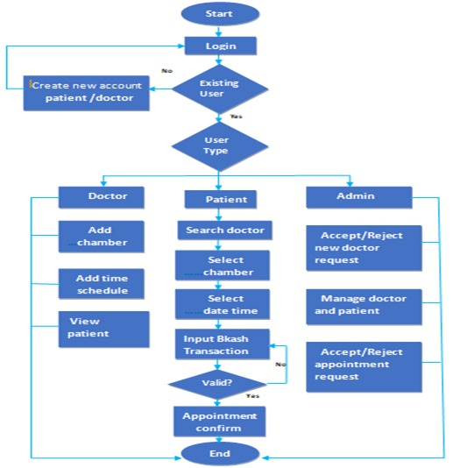

Flow chart of our Approach Fig(4.3.1)

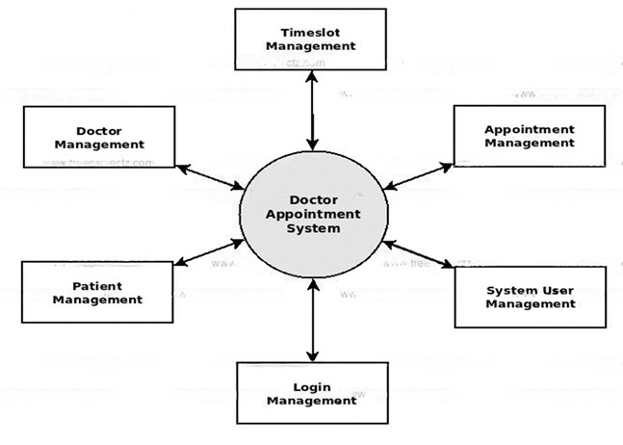

Functions in System Fig(4.3.2)

**4.4] UI Design**

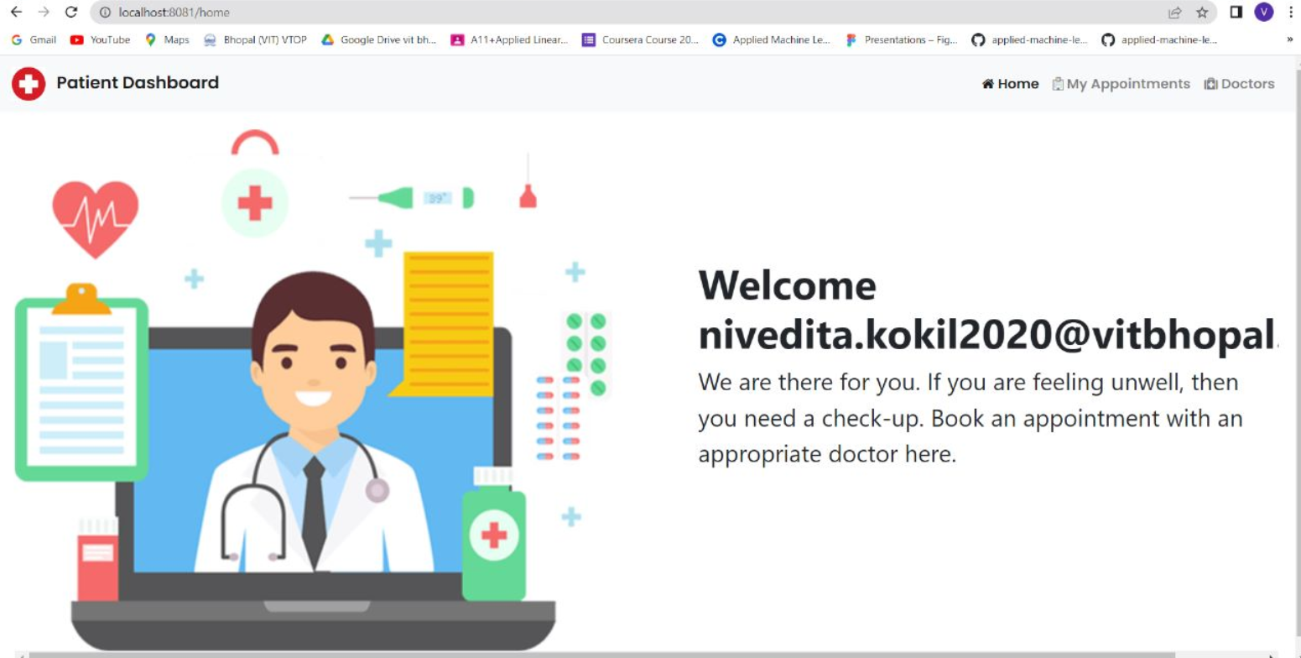

Home Page UI Fig(4.4.1)

**4.5] Summary**

Chapter 4 outlines the design methodology and novelty of the "Book a Doctor" project. It adopts Agile software development, emphasizing iterative development and collaboration. Functional modules are designed to address specific features like appointment scheduling, patient registration, and appointment notifications. Each module facilitates efficient development and testing, ensuring a user-friendly system for booking appointments with doctors. By leveraging Spring Boot technology, the project aims to create an intelligent solution that enhances patient satisfaction and optimizes resource utilization for healthcare organizations. Through systematic design and analysis, the project aims to deliver a reliable and efficient appointment scheduling system.

**CHAPTER-5:**

**TECHNICAL IMPLEMENTATION & ANALYSIS**

**5.1] Outline**

The technical implementation of the doctor appointment scheduling project involves leveraging Spring Boot technology and following MVC architecture principles for efficient development. Key features include user registration, doctor listing, appointment booking, appointment management, and doctor availability management. Spring Boot simplifies the development process by providing a robust framework for building web applications, while MVC architecture ensures separation of concerns and modularity. Thymeleaf templating facilitates dynamic rendering of web pages, enhancing the user interface. JPA is utilized for data persistence, with the H2 in-memory database enabling CRUD operations for user and appointment data. The analysis of the project focuses on evaluating the efficiency, scalability, usability, functionality, and reliability of the system. Performance testing assesses the system's responsiveness and ability to handle concurrent user requests. Functionality testing ensures that all features work as intended, with rigorous testing conducted to identify and address any bugs or issues. Overall, the goal is to deliver a robust, user-friendly, and reliable doctor appointment scheduling system that meets the needs of both patients and healthcare providers.

**5.2] Technical coding and code solutions**

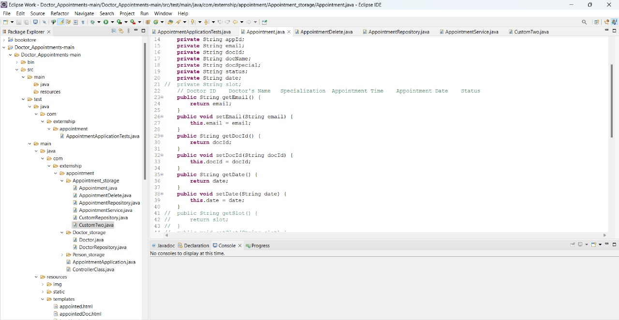

Appointment main.java Fig(5.2.1)

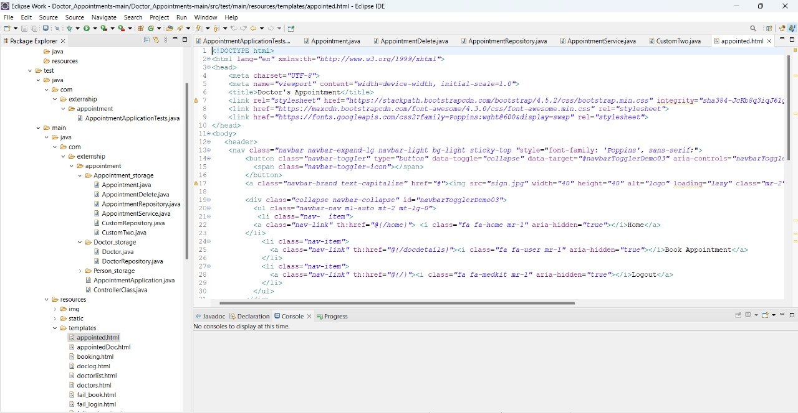

Home.html Fig(5.2.2)

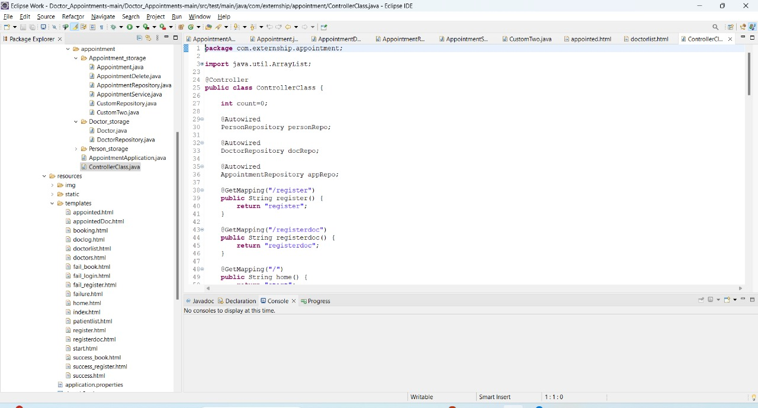

Controller class Fig(5.2.3)

**5.3] Working Layout of Forms**

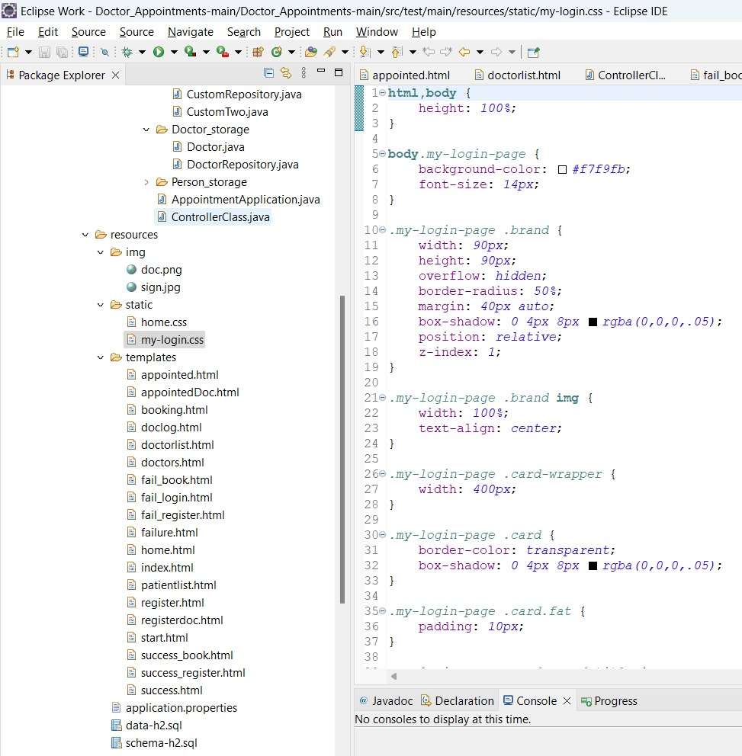

Login style.css Fig(5.3.1)

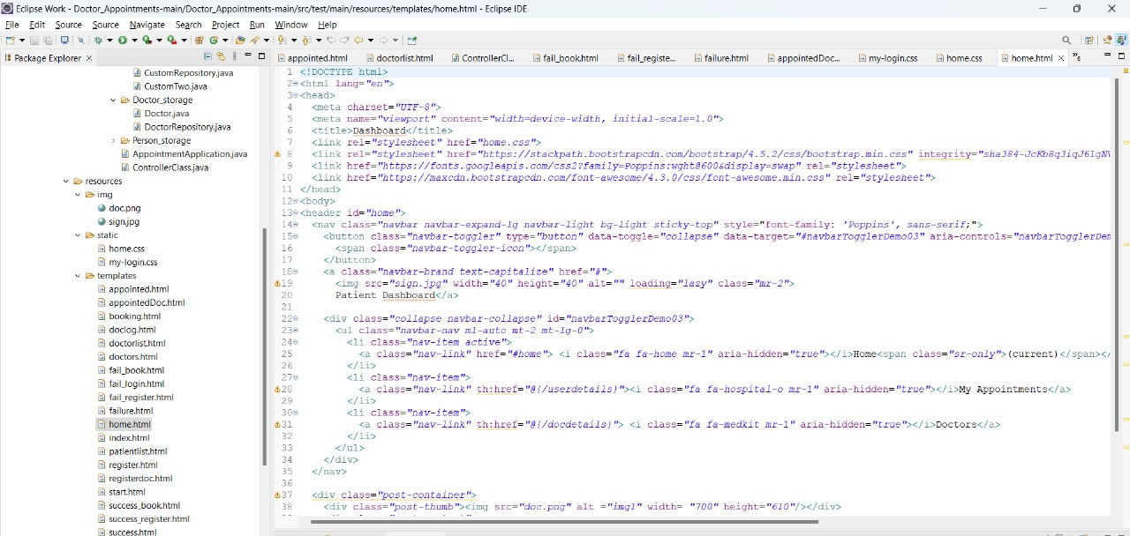

Patient List.html Fig(5.3.2)

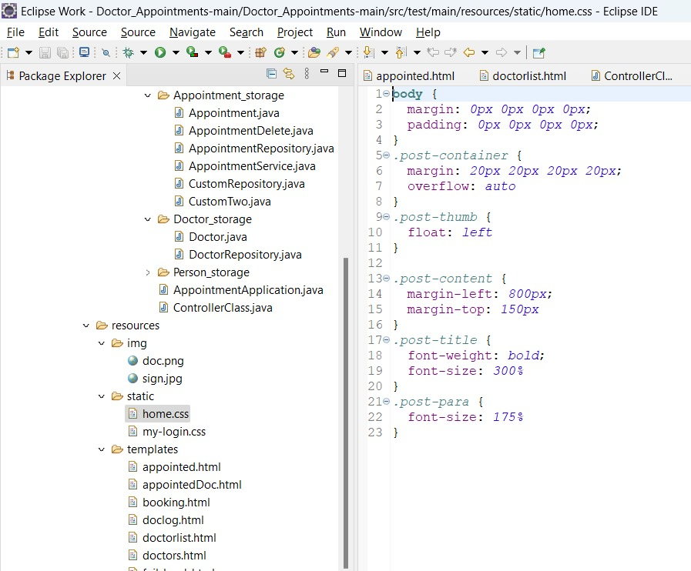

Home page Styling - Fig(5.3.3)

**5.4] Prototype submission**

The doctor appointment scheduling project aims to streamline the process of booking appointments with healthcare providers through an online platform. The prototype developed for this project leverages modern technologies such as Spring Boot, MVC architecture, and Thymeleaf templating to create a robust and user-friendly system. Users can register for accounts, search for doctors based on specialties or locations, and book appointments with their preferred healthcare providers. The system also allows for appointment management, enabling users to view and cancel appointments as needed. Additionally, doctors have the ability to manage their availability and appointments through the platform. This prototype represents a significant step forward in the development process, providing stakeholders with a tangible demonstration of the project's functionality and potential. Moving forward, the project will focus on refining the user interface, enhancing system scalability, and incorporating additional features based on user feedback to create a comprehensive and efficient doctor appointment scheduling solution.

**5.5] Test and Validation**

The "Book a Doctor" project undergoes rigorous testing and validation to ensure functionality and reliability. Testing involves running the application through various scenarios, including login credentials verification and database interactions. Validation confirms that the system accurately stores and retrieves user data from the MySQL database. Additionally, tests are conducted to ensure seamless navigation, appointment scheduling, and notification functionalities. Through systematic testing and validation procedures, the project verifies the integrity of the system, ensuring it meets user requirements and operates effectively in real-world scenarios.

**5.6] Performance Analysis(Graphs/Charts)**

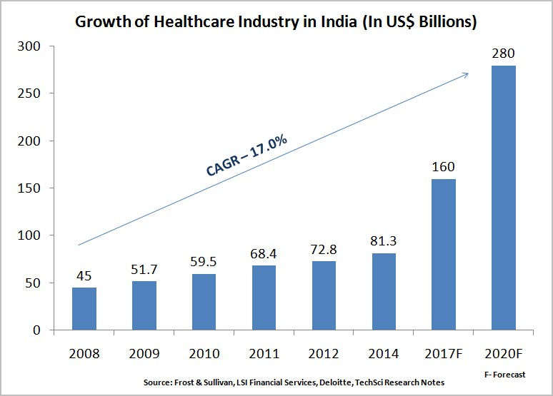

Fig(5.6.1)

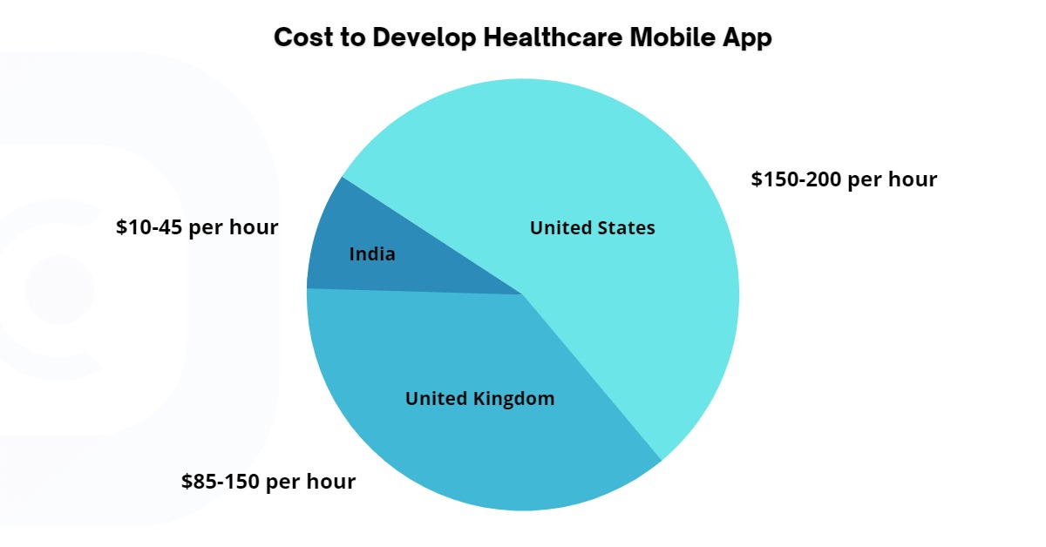

Fig(5.6.2)

Project Price Estimate of Online Appointment Booking App and Patient Management System. The project price includes the entire implementation of the application: from the technical and functional design to the submission. In view of the features listed, we at OneClick would suggest cross-platform development, by using Java framework called Spring Boot and Maven dependencies

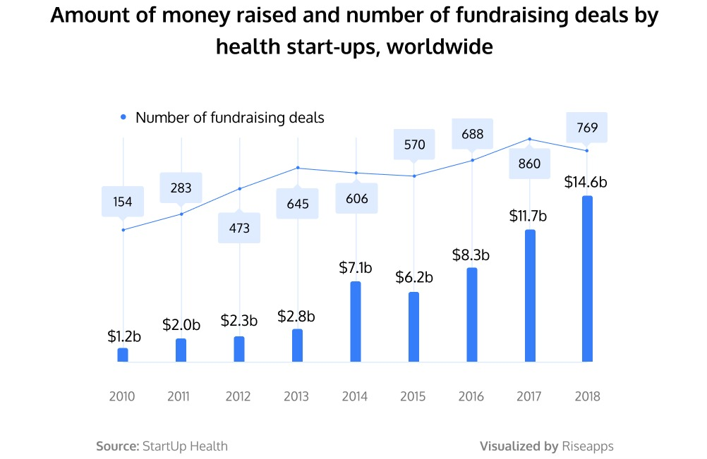

Fig(5.6.3)

The main concerns to be considered if discussing the eHealth market are security-related. Unauthorized attempts to gain access to medical records or individuals’ data must be addressed by companies creating remote healthcare solutions.

**5.7] Summary**

Chapter 5 delves into the technical implementation and analysis of the doctor appointment scheduling project. Leveraging Spring Boot technology and MVC architecture principles, the system facilitates efficient development and modularity. Templating enhances the user interface, while JPA and H2 database enable data persistence and CRUD operations. Performance, scalability, usability, functionality, and reliability are rigorously analyzed through testing procedures. The prototype demonstrates the system's functionality, allowing users to register, search for doctors, book appointments, and manage schedules. The chapter highlights the project's progress, emphasizing the goal of delivering a robust and user-friendly appointment scheduling solution.

**CHAPTER-6:**

**PROJECT OUTCOME AND APPLICABILITY**

**6.1] Outline**

The project outcome entails the development of a sophisticated doctor appointment scheduling system designed to streamline the process of booking appointments with healthcare providers. Through user-friendly interfaces and efficient functionalities, such as user registration, doctor listing, appointment booking, and management, the system aims to enhance accessibility and convenience for patients. Additionally, healthcare providers will benefit from features allowing them to manage their availability and appointments effectively. The applicability of this system extends across various healthcare settings, including hospitals, clinics, and private practices, where it can significantly improve operational efficiency and patient satisfaction. Overall, the project outcome promises to revolutionize the way healthcare appointments are scheduled and managed, ultimately enhancing the healthcare experience for both patients and providers.

**6.2] Key implementations outlines of the System**

The key implementation outlines of the doctor appointment scheduling system include:

1. User Registration: Implement functionality for users to create accounts, providing necessary information such as name, contact details, and medical history.
2. Doctor Listing: Develop a feature to list doctors based on specialties, locations, or names, allowing users to find and select their preferred healthcare providers.
3. Appointment Booking: Enable users to view available time slots and book appointments with their preferred doctors, facilitating seamless scheduling.
4. Appointment Management: Implement features for users to view, modify, or cancel their booked appointments, providing flexibility and convenience.
5. Doctor Availability Management: Allow healthcare providers to manage their availability and appointments, ensuring efficient scheduling and resource utilization.
6. User Interface Design: Design a user-friendly interface using Thyme leaf templating, ensuring ease of navigation and interaction for users.
7. Data Persistence: Utilize JPA for data persistence, storing user information, doctor profiles, and appointment details in the H2 in-memory database.

By implementing these key outlines, the system aims to provide a comprehensive and efficient solution for doctor appointment scheduling, benefiting both patients and healthcare providers.

**6.3] Significant project outcomes**

Significant project outcomes include the development of an intelligent web-based Doctor Appointment Scheduler, streamlining booking processes and enhancing patient experience. Leveraging Agile methodology and Spring Boot technology, the system offers efficient appointment management, secure data storage, and seamless user interactions, leading to improved healthcare accessibility and resource utilization.

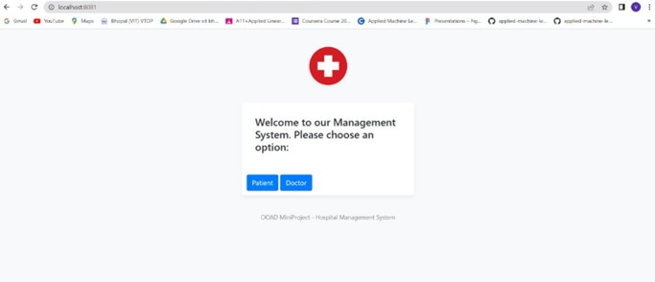

Welcome Page - Fig(6.3.1)

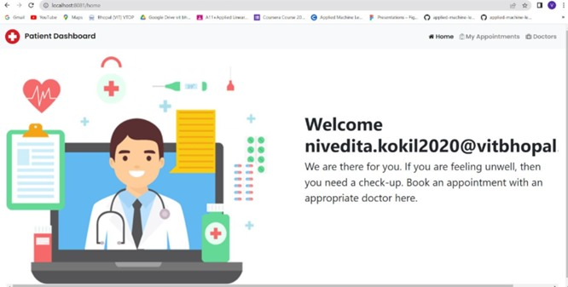

Home Page - Fig(6.3.2)

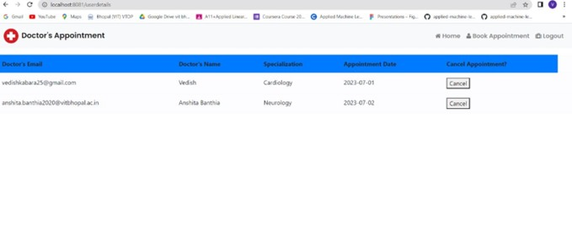

Appointment Page - Fig(6.3.3)

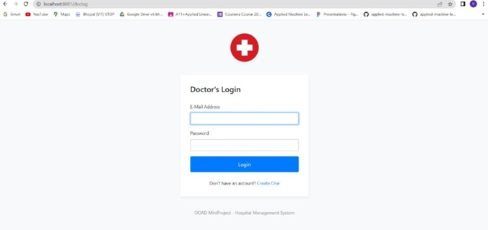

Doctors Login - Fig(6.3.4)

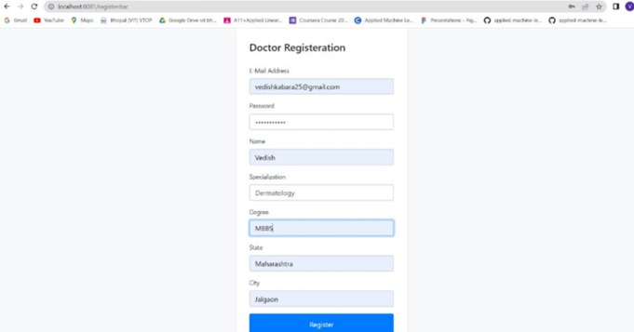

Doctors Registration - Fig(6.3.5)

**6.4] Project applicability on Real-world applications**

1. The proposed software product is the Appointment schedular System (HMS). The system will be used in any Hospital, Clinic, Dispensary or Pathology labs in any Hospital, Clinic, Dispensary or Pathology labs to get the information from the patients and then storing that data for future usage.
2. The intentions of the system are to reduce over-time pay and increase the number of patients that can be treated accurately.
3. This system includes registration of patients, storing their details into the system, and also booking their appointments with doctors.
4. Our software would be used to give a unique id for every patient and stores the details of every patient and the staff automatically. User can search availability of a doctor and the details of a patient using the id.
5. The administrator or receptionist can add data into the database. The data can be retrieved easily.
6. The data are well protected for personal use and makes the data processing very fast. The interface is very user-friendly.

**6.5] Inference**  
The project outcome delivers a sophisticated Doctor Appointment Scheduler, enhancing patient experience and operational efficiency. With user-friendly interfaces and robust functionalities, it streamlines appointment booking and management. Applicable across various healthcare settings, the system promises to revolutionize scheduling practices, benefiting both patients and providers with improved accessibility and convenience.

**CHAPTER-7:**

**CONCLUSIONS AND RECOMMENDATION**

**7.1] Outline**

In conclusion, the project aims to revolutionize the healthcare industry by developing an intelligent doctor appointment scheduling system. Through features such as user registration, doctor listing, appointment booking, and management, the system enhances accessibility and convenience for patients. Utilizing technologies like Spring Boot, MVC architecture, and Thyme leaf templating, the system ensures a user-friendly interface and efficient functionalities. With applicability across various healthcare settings, the system has the potential to improve operational efficiency and patient satisfaction. Overall, the project represents a significant step forward in streamlining the appointment scheduling process and enhancing the healthcare experience for both patients and providers.

**7.2] Limitation/Constraints of the System**

The doctor appointment scheduling system may encounter several limitations and constraints that could impact its functionality and usability. Firstly, limited scalability may pose challenges in handling a large influx of users or appointments, potentially leading to performance issues during peak times. Additionally, dependency on internet connectivity may restrict access to the system in areas with poor network coverage, limiting its accessibility for some users. Data security concerns also arise due to the storage of sensitive patient and doctor information, necessitating stringent measures to safeguard against unauthorized access or breaches. Compatibility issues with certain devices or browsers may affect user experience and accessibility, while reliance on technical support for troubleshooting may result in delays or downtime. Moreover, compliance with healthcare regulations such as HIPAA requires strict adherence to data protection and privacy guidelines, adding further constraints to system development and operation. Addressing these limitations through robust infrastructure, proactive measures, and adherence to regulatory standards is crucial to ensuring the system's effectiveness and reliability.

**7.3] Future Enhancements**   
The future scope of the Appointment Scheduler System encompasses integration with a pharmacy management system to track medication inventory. This expansion enhances user experience by providing comprehensive healthcare support. Additionally, incorporating telemedicine functionalities for remote consultations can broaden accessibility. Moreover, implementing data analytics capabilities can offer insights into appointment trends and resource utilization, optimizing service delivery. Further enhancements may include personalized patient portals for health records management and automated appointment reminders. By continuously evolving with technological advancements and user needs, the system can become a holistic healthcare solution, catering to diverse patient requirements and improving overall healthcare delivery.

**7.4] Inference**

In conclusion, the development of the Doctor Appointment Scheduler represents a significant advancement in healthcare technology. By leveraging intelligent scheduling systems and user-friendly interfaces, the project streamlines appointment booking processes, enhancing accessibility and convenience for patients. Despite potential limitations such as scalability constraints and data security concerns, the system's future enhancements, including pharmacy integration and telemedicine functionalities, promise to further revolutionize healthcare delivery. With continuous evolution and adherence to regulatory standards, this system holds immense potential to optimize resource utilization, improve patient satisfaction, and ultimately transform the healthcare experience for both patients and providers.

**REFERENCES**

1. <https://www.studocu.com/in/document/maharashtra-university-of-health-sciences/mbbs-2nd-year/problem-statementvirtual-patient-appointment-feature-srs/23552661>
2. <https://www.ccdcare.com/resource-center/outpatient-appointment-scheduling-types>
3. <https://github.com/Nivedita1103/Doctor_appointment/blob/main/Group421.mp4>
4. <https://www.google.com/url?sa=i&url=https%3A%2F%2Friseapps.co%2Fhow-to-create-a-doctor-appointment-app%2F&psig=AOvVaw2U0qdmnOlgV5zCEphDGaZC&ust=1713864011548000&source=images&cd=vfe&opi=89978449&ved=0CBQQjhxqFwoTCIjjwI-_1YUDFQAAAAAdAAAAABA9>
5. <https://www.google.com/url?sa=i&url=https%3A%2F%2Fwww.oneclickitsolution.com%2Fblog%2Fwhat-will-it-cost-to-develop-an-app-of-doctor-appointment-booking-system%2F&psig=AOvVaw2U0qdmnOlgV5zCEphDGaZC&ust=1713864011548000&source=images&cd=vfe&opi=89978449&ved=0CBQQjhxqFwoTCIjjwI-_1YUDFQAAAAAdAAAAABA1>
6. <https://www.google.com/url?sa=i&url=https%3A%2F%2Fwww.fatbit.com%2Ffab%2Fscript-features-worth-considering-launch-successful-doctor-appointment-scheduling-platform%2F&psig=AOvVaw2U0qdmnOlgV5zCEphDGaZC&ust=1713864011548000&source=images&cd=vfe&opi=89978449&ved=0CBQQjhxqFwoTCIjjwI-_1YUDFQAAAAAdAAAAABAt>